Exercise 1: Implementing the Singleton Pattern

SingletonTest.java

public class SingletonTest {

public static void main(String[] args) {

Logger logger1 = Logger.getInstance();

logger1.log("First log message");

Logger logger2 = Logger.getInstance();

logger2.log("Second log message");

if (logger1 == logger2) {

System.out.println("Both logger1 and logger2 are the same instance.");

} else {

System.out.println("Different Logger instances exist!");

}

}

}

Logger.java

public class Logger {

private static Logger instance;

private Logger() {

System.out.println("Logger Initialized.");

}

public static Logger getInstance() {

if (instance == null) {

instance = new Logger();

}

return instance;

}

public void log(String message) {

System.out.println("Log: " + message);

}

}

Output

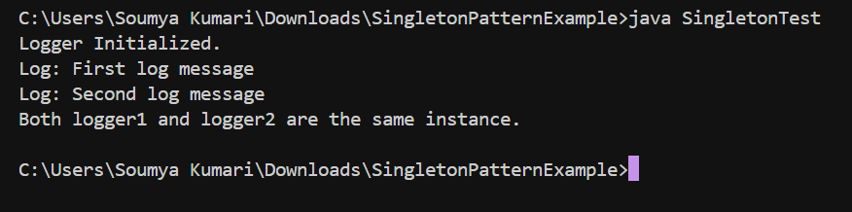

Exercise 2: Implementing the Factory Method Pattern

Document.java

public interface Document {

void open();

}

WordDocument.java

public class WordDocument implements Document {

@Override

public void open() {

System.out.println("Opening Word Document.");

}

}

PdfDocument.java

public class PdfDocument implements Document {

@Override

public void open() {

System.out.println("Opening PDF Document.");

}

}

ExcelDocument.java

public class ExcelDocument implements Document {

@Override

public void open() {

System.out.println("Opening Excel Document.");

}

}

DocumentFactory.java

public abstract class DocumentFactory {

public abstract Document createDocument();

}

WordDocumentFactory.java

public class WordDocumentFactory extends DocumentFactory {

@Override

public Document createDocument() {

return new WordDocument();

}

}

PdfDocumentFactory.java

public class PdfDocumentFactory extends DocumentFactory {

@Override

public Document createDocument() {

return new PdfDocument();

}

}

ExcelDocumentFactory.java

public class ExcelDocumentFactory extends DocumentFactory {

@Override

public Document createDocument() {

return new ExcelDocument();

}

}

FactoryTest.java

public class FactoryTest {

public static void main(String[] args) {

DocumentFactory wordFactory = new WordDocumentFactory();

Document wordDoc = wordFactory.createDocument();

wordDoc.open();

DocumentFactory pdfFactory = new PdfDocumentFactory();

Document pdfDoc = pdfFactory.createDocument();

pdfDoc.open();

DocumentFactory excelFactory = new ExcelDocumentFactory();

Document excelDoc = excelFactory.createDocument();

excelDoc.open();

}

}

Output :

